**Creating an Annotated Bibliography**

An Annotated Bibliography is a formatted list of researched sources that includes a brief evaluation of each source. It consists of alphabetically organized entries in MLA format, followed by these brief comments. These annotations range from a short phrase or sentence to a paragraph. These descriptive paragraphs, or annotations, are usually less than 150 words in length and are meant to demonstrate the accuracy, quality and relevance of the sources relation to the topic being researched.

* A descriptive annotation summarizes the source.
* A critical annotation evaluates the source and compares it to others.

Initially evaluate each source for relevance and add it to your preliminary or working bibliography. In the annotation field, jot down anything you notice about the content and author. Later you’ll revise these initial impressions to answer the questions:

* What’s the **scope** and purpose?
* Why is the author an **expert**?

After a good draft of the paper or product has been developed, the source’s specific value to the research process will become clearer.

**Question #1: What's the scope and purpose?**

A descriptive annotation briefly explains the document’s content, coverage or scope. Consider the time and format of publication and the author’s purpose and audience. Choose language that shows how the entry is related to the topic.

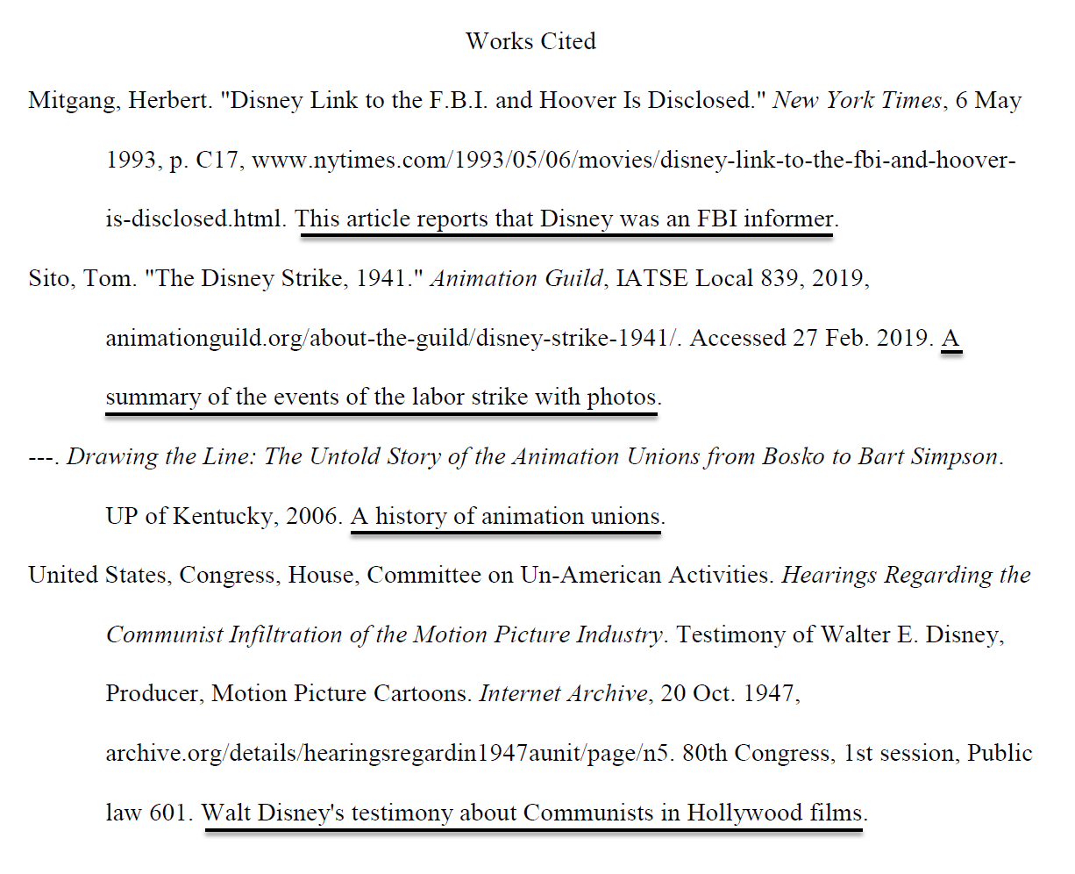

These annotations are either concise phrases or single sentences.

**Question #2: Why is the author an expert?**

A slightly longer annotation includes the author’s relevant credentials or expertise. Notice why the description of the author’s expertise changes in the two entries by Tom Sito below.

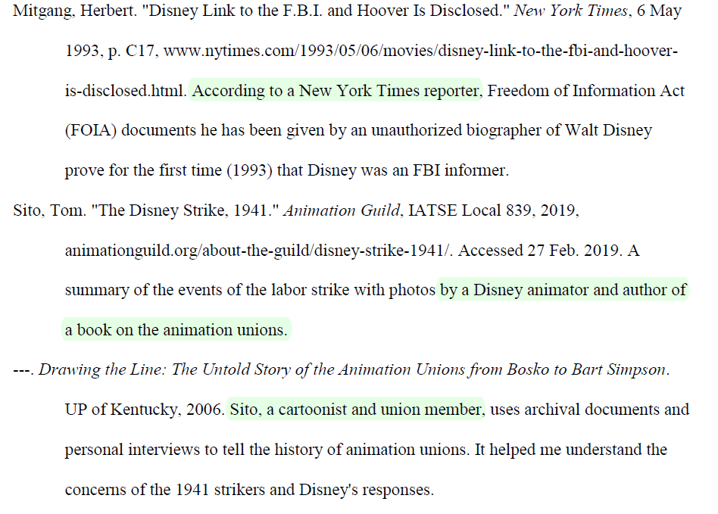

Annotations explain why the author of the source is a credible expert.

**Question #3: What's the source's value?**

Sources have value in both learning about a topic and creating a product:

1. **Learning:** Has the source contributed to your knowledge, interpretation or empathy?
2. **Creating or Writing:** Is the source being used to substantiate an argument or thesis? Does it amplify an interpretation or help refute a claim? Is the product stronger, clearer and more accurate as a result?

The usefulness of a source is easier to appreciate after a rough draft has been written. In fact, explaining its value in the annotation may prompt you to make more effective use of it.

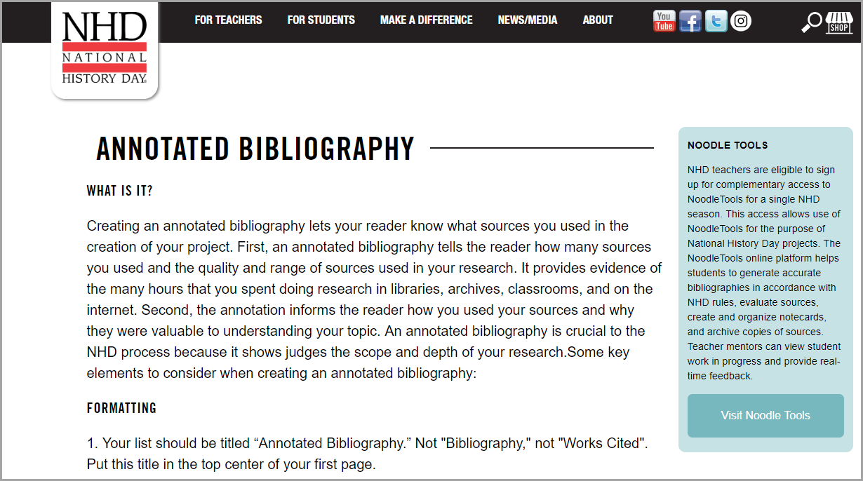

A description of the requirements for a National History Day annotated bibliography.

**Last step - polish!**

To revise annotations, use the **RACU** acronym:

**R = Redundancy**. Is each source of unique value? Delete those that pad but don’t add! (Don’t worry, they can be undeleted if you change your mind.).

**A = Authority.** What relevant knowledge or expertise does this author bring to this topic? Identify specialization, not just general credentials.

**C = Context.** How does the historical context (the time and circumstances of its creation) and/or the publishing context (the process and format of its publication) relate to the topic?

**U = Use.** Why was this document useful? Indicate it’s unique value for learning about the topic and/or writing the argument or creating the product.

From NoodleTools [www.NoodleTools.com](http://www.NoodleTools.com)